

**Final Project Template**



The capstone project is meant to be a fun and fulfilling experience for students to demonstrate what they have learned over the course of the curriculum. The student will be able to choose the techniques they want to implement but will have to follow the requirements given to meet the minimum standards of the project.



**Business Problem:**

Think of a problem that needs to be solved and how Data Science can help solve this problem. Make sure that you understand how Data Science plays a role but also how your solution will drive business impact. Business impact can be defined in many ways using a multitude of metrics. What matters is that you understand the exact problem you want to solve.

**Data:**

Outline what data you will need to solve your business problem. Do not limit yourself to one data source. Consider merging multiple data sources together to help create a comprehensive dataset with many features and observations. If you cannot find relevant data for your business problem then you will need to adjust the scope of your business problem so you are able to complete the project. Data should have at least 10 features and more than 1000 observations. 

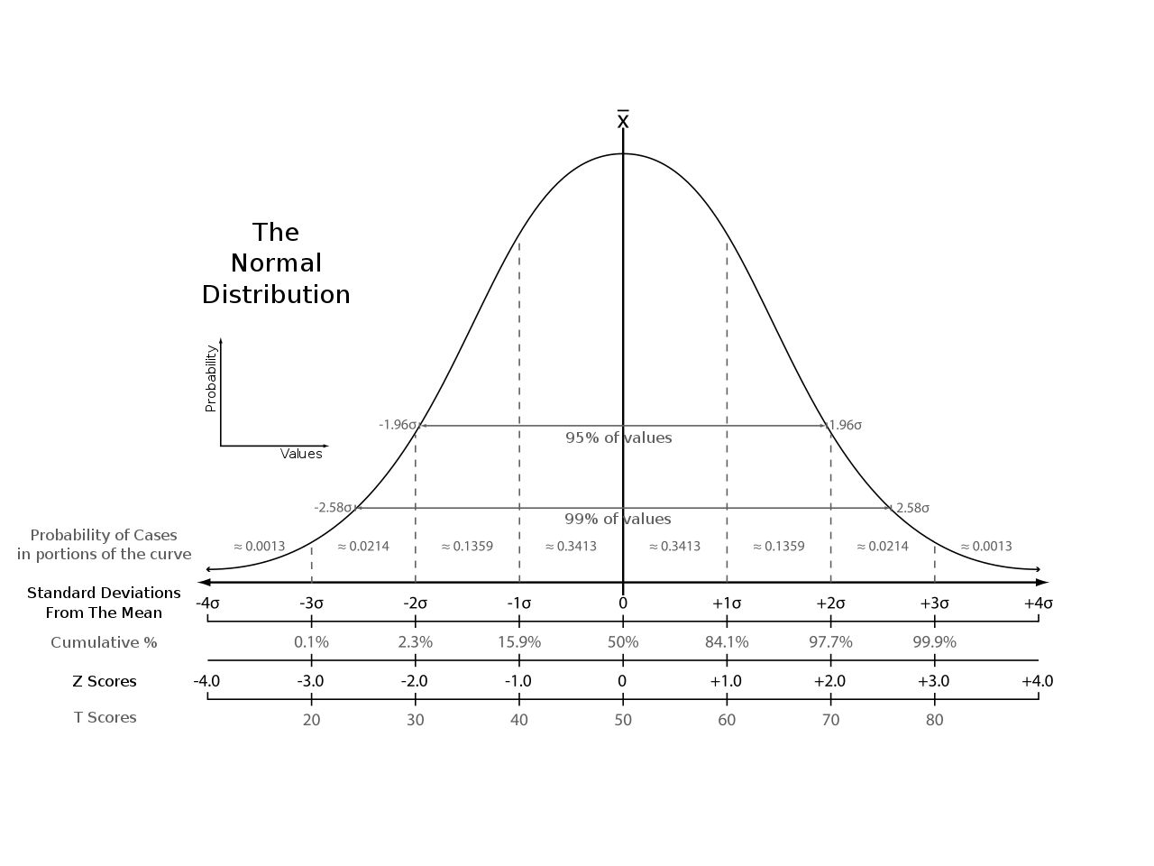

**Visualize:**

Be prepared to make 6 plots explaining different insights in your Data. The plots should be easy to read and include axis labels along with a title. The visuals can be interactive and it is encouraged to make more than 6 plots. If you are only making the minimum number of plots, then plots must address your business problem directly.

**Model:**

Build a model of your choice with the attempt of solving your business problem. You will not be graded on accuracy and it is more important that you are implementing your techniques correctly. Even if your model does not return your intended results. If your model does not provide sufficient accuracy levels, make sure to present your work while explaining

Possible reasons behind this shortfall.

**Write:**

Write a minimum 500-word blog explaining your research. Explain your business problem, the plots, your approach, results, and what can be improved in detail. This is your opportunity to display how you’re able to communicate effectively to a wide audience. The blog should not contain code or talk about your data cleaning process. The blog is meant to only talk about your results and findings. The blog should be posted either in the README.md of your GitHub repo or published on a website of your choice (personal website, medium, WordPress, etc.)



**Code:**

Post all code to GitHub in its own repository for anyone to see. Make sure to add any relevant notebooks and data here. Your code should be well commented so anyone reading it can easily follow your logic. This includes using markdown when necessary.

**Presentation:**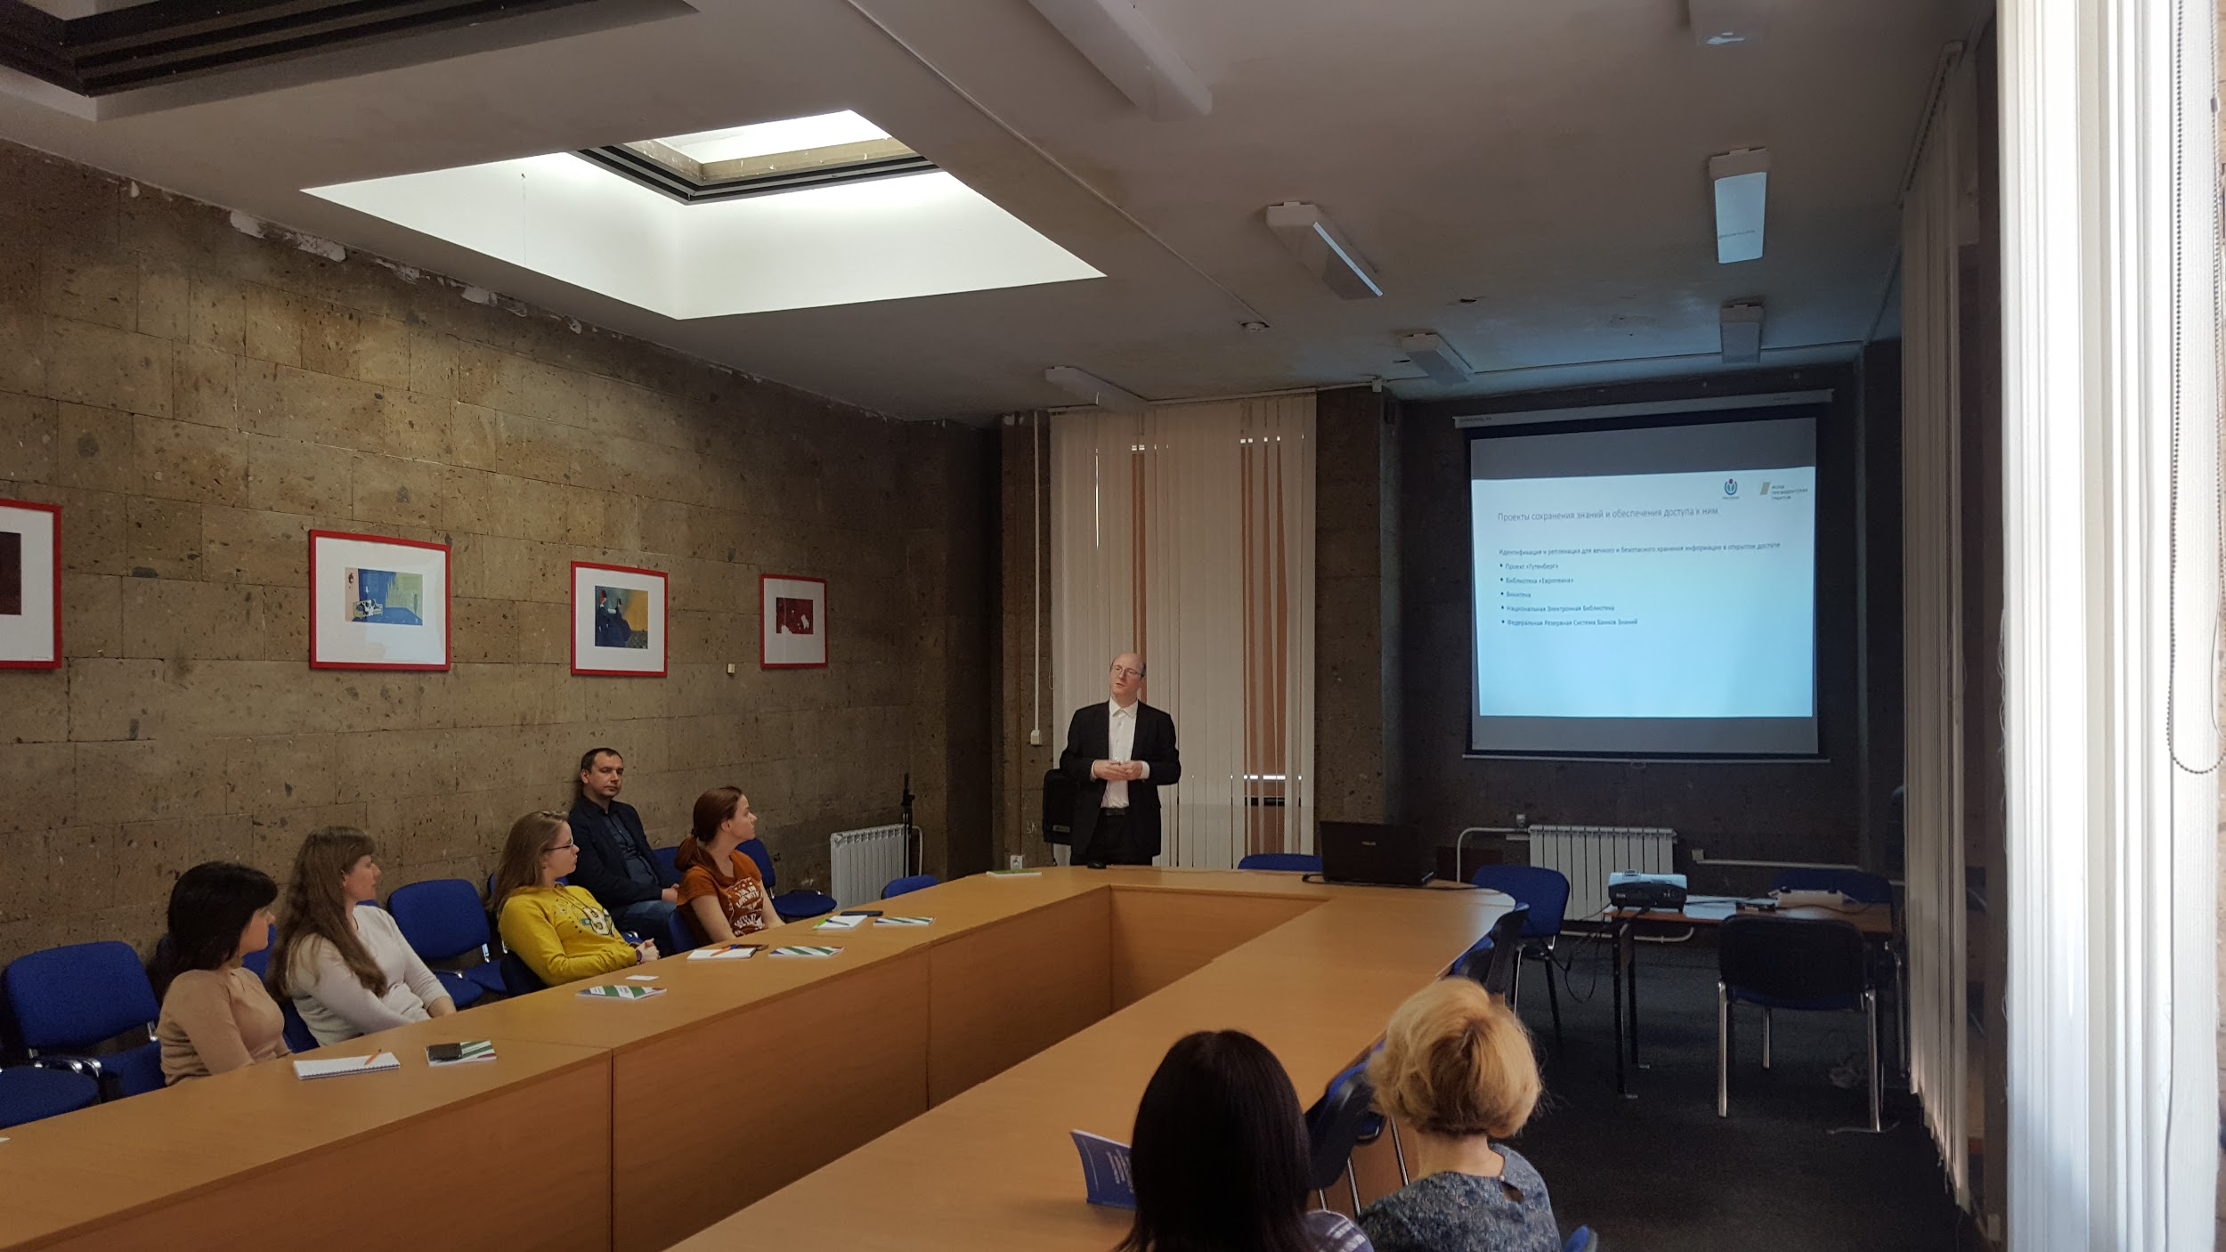

Be prepared to make a 20 minutes presentation about your findings to the class. This will require you to share your screen and show everyone the work you have done. All presentations will be timed and you will be stopped if you go over time. Please take time to practice your presentation out loud and plan how you will display your results to your peers. Make sure to dedicate enough time to go through your code, explain how it works, or even live code your project is encouraged.

**Tableau 1-Page Dashboard:**

So that people can easily understand what your project is, and what it’s about, you will make a condensed, 1 page summary / overview. This 1 page should show explains your project and highlights what you have done along with your results. This format is similar to research posters but you can be creative and try to develop interactive plots and sections rather than static images.

You can find [some examples here](https://drive.google.com/drive/folders/1_YHSa3tvN_Si06yluMdn1I-JErAwSQGQ?usp=sharing).

**Submission:**

Please fill out the Google Sheet [here](https://docs.google.com/spreadsheets/d/1tqaw7O79QVGpxjkKd-y04bODtssdQU_Z/edit?usp=sharing&ouid=108342847732726257413&rtpof=true&sd=true) and submit your:

1. Team Name
2. Members Names
3. Team Leader Name and Email
4. Presentation Title
5. Data URL (Where you found your data)
6. Data Shape (How many rows and columns)
7. Target Column If Applicable (What column your model will predict)
8. Submission Date (The date when you submitted your data)